Report On

ONLINE SHOPPING SYSTEM

Submitted in fulfillment of the requirements for Mini project on Python in

FE Internship Programme

By

Pritish Mair (D - 20)

Sharvin Dedhia (D - 06)

Soham Waghmare (D - 61)

Supervisor

Prof. Priya Save

Prof. Sneha Mhatre

**Vidyavardhini's College of Engineering & Technology**



**(2019-20)**

**SOURCE CODE :**

from tkinter import *

from tkinter import messagebox

import tkinter.font as tkFont

shop = Tk()

def about():

messagebox.showinfo(

"About GenCoders", "GenCoders is The Coding Team of VCET, we specialize in doing wonders and stuff that others do not think about doing.\n"

"Founders : Pritish Mair -- Sharvin Dedhia -- Soham Waghmare")

def exitbut():

shop.destroy()

pquanta = []

pname = []

def addcart(numb, name):

pquanta.append(numb)

pname.append(name)

def viewC():

cartv = Toplevel(shop)

quan = "The Quantity of "

eq = " = "

totap = "The Total Price of "

print(pname)

labels1 = []

labels2 = []

if (len(pname) == 0):

empty="Your Cart is Empty"

emplab= Label(cartv,text=empty)

emplab.pack()

else:

for i in range(0, len(pquanta)):

stat1 = quan + pname[int(i)] + eq + pquanta[int(i)]

stat2 = totap + pname[int(i)] + eq + str((int(pquanta[int(i)])*100))

label1 = Label(cartv, text=stat1)

label1.pack()

label2 = Label(cartv, text=stat2)

label2.pack()

labels1.append(label1)

labels2.append(label2)

def log():

def exitbutlog():

newL.destroy()

newL = Toplevel(w1)

label_1 = Label(newL, text="Username")

label_2 = Label(newL, text="Password")

entry_1 = Entry(newL)

entry_2 = Entry(newL, show="*")

label_1.grid(row=0)

label_2.grid(row=1)

entry_1.grid(row=0, column=1)

entry_2.grid(row=1, column=1)

c = Checkbutton(newL, text="Keep me logged in")

c.grid(columnspan=2)

submit = Button(newL, text="Submit", command=exitbutlog)

submit.grid(columnspan=3)

def clothes():

def exitClo():

cloth.destroy()

cloth = Toplevel(shop)

#product list 1 of clothes

fontStyle1 = tkFont.Font(family="Lucida Grande", size=10)

pro1 = Message(cloth, text="Tshirt", font=fontStyle1)

photo1 = PhotoImage(file="tshirt.PNG")

l1 = Label(cloth, image=photo1, text="Total Cost = 100",

font=fontStyle1, compound=TOP)

l1.photo = photo1

quantity1 = Spinbox(cloth, from_=0, to=100)

but1 = Button(cloth, text="Add to Cart", font=fontStyle1,

command=lambda: addcart(quantity1.get(), "T-Shirt1"))

pro2 = Message(cloth, text="Pant", font=fontStyle1)

photo2 = PhotoImage(file="pant.PNG")

l2 = Label(cloth, image=photo2, text="Total cost=100",

font=fontStyle1, compound=TOP)

l2.photo = photo2

quantity2 = Spinbox(cloth, from_=0, to=100)

but2 = Button(cloth, text="Add to cart", font=fontStyle1,

command=lambda: addcart(quantity2.get(), "Pant1"))

pro3 = Message(cloth, text="Coat", font=fontStyle1)

photo3 = PhotoImage(file="coat.PNG")

l3 = Label(cloth, image=photo3, text="Total cost = 100",

font=fontStyle1, compound=TOP)

l3.photo = photo3

quantity3 = Spinbox(cloth, from_=0, to=100)

but3 = Button(cloth, text="Add to cart", font=fontStyle1,

command=lambda: addcart(quantity3.get(), "Coat1"))

pro1.grid()

l1.grid()

quantity1.grid()

but1.grid()

pro2.grid()

l2.grid()

quantity2.grid()

but2.grid()

pro3.grid()

l3.grid()

quantity3.grid()

but3.grid()

#product list 2 of clothes

pro4 = Message(cloth, text="Tshirt", font=fontStyle1)

photo4 = PhotoImage(file="tshirt.PNG")

l4 = Label(cloth, image=photo4, text="Total Cost = 100",

font=fontStyle1, compound=TOP)

l4.photo = photo4

quantity4 = Spinbox(cloth, from_=0, to=100)

but4 = Button(cloth, text="Add to Cart", font=fontStyle1,

command=lambda: addcart(quantity4.get(), "T-Shirt2"))

pro5 = Message(cloth, text="Pant", font=fontStyle1)

photo5 = PhotoImage(file="pant.PNG")

l5 = Label(cloth, image=photo5, text="Total cost=100",

font=fontStyle1, compound=TOP)

l5.photo = photo5

quantity5 = Spinbox(cloth, from_=0, to=100)

but5 = Button(cloth, text="Add to cart", font=fontStyle1,

command=lambda: addcart(quantity5.get(), "Pant2"))

pro6 = Message(cloth, text="Coat", font=fontStyle1)

photo6 = PhotoImage(file="coat.PNG")

l6 = Label(cloth, image=photo6, text="Total cost = 100",

font=fontStyle1, compound=TOP)

l6.photo = photo6

quantity6 = Spinbox(cloth, from_=0, to=100)

but6 = Button(cloth, text="Add to cart", font=fontStyle1,

command=lambda: addcart(quantity6.get(), "Coat2"))

pro4.grid(row=0, column=1)

l4.grid(row=1, column=1)

quantity4.grid(row=2, column=1)

but4.grid(row=3, column=1)

pro5.grid(row=4, column=1)

l5.grid(row=5, column=1)

quantity5.grid(row=6, column=1)

but5.grid(row=7, column=1)

pro6.grid(row=8, column=1)

l6.grid(row=9, column=1)

quantity6.grid(row=10, column=1)

but6.grid(row=11, column=1)

#product list 3 of clothes

pro7 = Message(cloth, text="Tshirt", font=fontStyle1)

photo7 = PhotoImage(file="tshirt.PNG")

l7 = Label(cloth, image=photo7, text="Total Cost = 100",

font=fontStyle1, compound=TOP)

l7.photo = photo7

quantity7 = Spinbox(cloth, from_=0, to=100)

but7 = Button(cloth, text="Add to Cart", font=fontStyle1,

command=lambda: addcart(quantity7.get(), "T-Shirt3"))

pro8 = Message(cloth, text="Pant", font=fontStyle1)

photo8 = PhotoImage(file="pant.PNG")

l8 = Label(cloth, image=photo8, text="Total cost=100",

font=fontStyle1, compound=TOP)

l8.photo = photo8

quantity8 = Spinbox(cloth, from_=0, to=100)

but8 = Button(cloth, text="Add to cart", font=fontStyle1,

command=lambda: addcart(quantity8.get(), "Pant3"))

pro9 = Message(cloth, text="Coat", font=fontStyle1)

photo9 = PhotoImage(file="coat.PNG")

l9 = Label(cloth, image=photo9, text="Total cost = 100",

font=fontStyle1, compound=TOP)

l9.photo = photo9

quantity9 = Spinbox(cloth, from_=0, to=100)

but9 = Button(cloth, text="Add to cart", font=fontStyle1,

command=lambda: addcart(quantity9.get(), "Coat3"))

pro7.grid(row=0, column=2)

l7.grid(row=1, column=2)

quantity7.grid(row=2, column=2)

but7.grid(row=3, column=2)

pro8.grid(row=4, column=2)

l8.grid(row=5, column=2)

quantity8.grid(row=6, column=2)

but8.grid(row=7, column=2)

pro9.grid(row=8, column=2)

l9.grid(row=9, column=2)

quantity9.grid(row=10, column=2)

but9.grid(row=11, column=2)

exitbu = Button(cloth, text="BACK", padx=100, pady=15, command=exitClo)

exitbu.grid(columnspan=3)

def shoes():

def exitShoe():

shoe.destroy()

shoe = Toplevel(shop)

#product list 1 of shoe

fontStyle1 = tkFont.Font(family="Lucida Grande", size=10)

pro1 = Message(shoe, text="Sports", font=fontStyle1)

photo1 = PhotoImage(file="sport.PNG")

l1 = Label(shoe, image=photo1, text="Total Cost = 100",

font=fontStyle1, compound=TOP)

l1.photo = photo1

quantity1 = Spinbox(shoe, from_=0, to=100)

but1 = Button(shoe, text="Add to Cart", font=fontStyle1,

command=lambda: addcart(quantity1.get(), "Sport1"))

pro2 = Message(shoe, text="Casuals", font=fontStyle1)

photo2 = PhotoImage(file="casual.PNG")

l2 = Label(shoe, image=photo2, text="Total cost=100",

font=fontStyle1, compound=TOP)

l2.photo = photo2

quantity2 = Spinbox(shoe, from_=0, to=100)

but2 = Button(shoe, text="Add to cart", font=fontStyle1,

command=lambda: addcart(quantity2.get(), "Casuals1"))

pro3 = Message(shoe, text="Sneakers", font=fontStyle1)

photo3 = PhotoImage(file="sneaker.PNG")

l3 = Label(shoe, image=photo3, text="Total cost = 100",

font=fontStyle1, compound=TOP)

l3.photo = photo3

quantity3 = Spinbox(shoe, from_=0, to=100)

but3 = Button(shoe, text="Add to cart", font=fontStyle1,

command=lambda: addcart(quantity3.get(), "Sneakers1"))

pro1.grid()

l1.grid()

quantity1.grid()

but1.grid()

pro2.grid()

l2.grid()

quantity2.grid()

but2.grid()

pro3.grid()

l3.grid()

quantity3.grid()

but3.grid()

#product list 2 of shoe

pro4 = Message(shoe, text="Sports", font=fontStyle1)

photo4 = PhotoImage(file="sport.PNG")

l4 = Label(shoe, image=photo4, text="Total Cost = 100",

font=fontStyle1, compound=TOP)

l4.photo = photo4

quantity4 = Spinbox(shoe, from_=0, to=100)

but4 = Button(shoe, text="Add to Cart", font=fontStyle1,

command=lambda: addcart(quantity4.get(), "Sports2"))

pro5 = Message(shoe, text="Casuals", font=fontStyle1)

photo5 = PhotoImage(file="casual.PNG")

l5 = Label(shoe, image=photo5, text="Total cost=100",

font=fontStyle1, compound=TOP)

l5.photo = photo5

quantity5 = Spinbox(shoe, from_=0, to=100)

but5 = Button(shoe, text="Add to cart", font=fontStyle1,

command=lambda: addcart(quantity5.get(), "Casuals2"))

pro6 = Message(shoe, text="Sneakers", font=fontStyle1)

photo6 = PhotoImage(file="sneaker.PNG")

l6 = Label(shoe, image=photo6, text="Total cost = 100",

font=fontStyle1, compound=TOP)

l6.photo = photo6

quantity6 = Spinbox(shoe, from_=0, to=100)

but6 = Button(shoe, text="Add to cart", font=fontStyle1,

command=lambda: addcart(quantity6.get(), "Sneakers2"))

pro4.grid(row=0, column=1)

l4.grid(row=1, column=1)

quantity4.grid(row=2, column=1)

but4.grid(row=3, column=1)

pro5.grid(row=4, column=1)

l5.grid(row=5, column=1)

quantity5.grid(row=6, column=1)

but5.grid(row=7, column=1)

pro6.grid(row=8, column=1)

l6.grid(row=9, column=1)

quantity6.grid(row=10, column=1)

but6.grid(row=11, column=1)

#product list 3 of shoe

pro7 = Message(shoe, text="Sports", font=fontStyle1)

photo7 = PhotoImage(file="sport.PNG")

l7 = Label(shoe, image=photo7, text="Total Cost = 100",

font=fontStyle1, compound=TOP)

l7.photo = photo7

quantity7 = Spinbox(shoe, from_=0, to=100)

but7 = Button(shoe, text="Add to Cart", font=fontStyle1,

command=lambda: addcart(quantity7.get(), "Sports3"))

pro8 = Message(shoe, text="Casuals", font=fontStyle1)

photo8 = PhotoImage(file="casual.PNG")

l8 = Label(shoe, image=photo8, text="Total cost=100",

font=fontStyle1, compound=TOP)

l8.photo = photo8

quantity8 = Spinbox(shoe, from_=0, to=100)

but8 = Button(shoe, text="Add to cart", font=fontStyle1,

command=lambda: addcart(quantity8.get(), "Casuals3"))

pro9 = Message(shoe, text="Sneakers", font=fontStyle1)

photo9 = PhotoImage(file="sneaker.PNG")

l9 = Label(shoe, image=photo9, text="Total cost = 100",

font=fontStyle1, compound=TOP)

l9.photo = photo9

quantity9 = Spinbox(shoe, from_=0, to=100)

but9 = Button(shoe, text="Add to cart", font=fontStyle1,

command=lambda: addcart(quantity9.get(), "Sneakers3"))

pro7.grid(row=0, column=2)

l7.grid(row=1, column=2)

quantity7.grid(row=2, column=2)

but7.grid(row=3, column=2)

pro8.grid(row=4, column=2)

l8.grid(row=5, column=2)

quantity8.grid(row=6, column=2)

but8.grid(row=7, column=2)

pro9.grid(row=8, column=2)

l9.grid(row=9, column=2)

quantity9.grid(row=10, column=2)

but9.grid(row=11, column=2)

exitbut = Button(shoe, text="BACK", padx=100, pady=15, command=exitShoe)

exitbut.grid(columnspan=3)

def television():

def exitTel():

tele.destroy()

tele = Toplevel(shop)

#product list 1 of television

fontStyle1 = tkFont.Font(family="Lucida Grande", size=10)

pro1 = Message(tele, text="Samsung", font=fontStyle1, width=60)

photo1 = PhotoImage(file="tv1.PNG")

l1 = Label(tele, image=photo1, text="Total Cost = 100",

font=fontStyle1, compound=TOP)

l1.photo = photo1

quantity1 = Spinbox(tele, from_=0, to=100)

but1 = Button(tele, text="Add to Cart", font=fontStyle1,

command=lambda: addcart(quantity1.get(), "Samsung1"))

pro2 = Message(tele, text="Hitachi", font=fontStyle1, width=60)

photo2 = PhotoImage(file="tv2.PNG")

l2 = Label(tele, image=photo2, text="Total cost=100",

font=fontStyle1, compound=TOP)

l2.photo = photo2

quantity2 = Spinbox(tele, from_=0, to=100)

but2 = Button(tele, text="Add to cart", font=fontStyle1,

command=lambda: addcart(quantity2.get(), "Hitachi"))

pro3 = Message(tele, text="Sony", font=fontStyle1, width=60)

photo3 = PhotoImage(file="tv3.PNG")

l3 = Label(tele, image=photo3, text="Total cost = 100",

font=fontStyle1, compound=TOP)

l3.photo = photo3

quantity3 = Spinbox(tele, from_=0, to=100)

but3 = Button(tele, text="Add to cart", font=fontStyle1,

command=lambda: addcart(quantity3.get(), "Sony1"))

pro1.grid()

l1.grid()

quantity1.grid()

but1.grid()

pro2.grid()

l2.grid()

quantity2.grid()

but2.grid()

pro3.grid()

l3.grid()

quantity3.grid()

but3.grid()

#product list 2 of television

pro4 = Message(tele, text="Samsung", font=fontStyle1, width=60)

photo4 = PhotoImage(file="tv1.PNG")

l4 = Label(tele, image=photo4, text="Total Cost = 100",

font=fontStyle1, compound=TOP)

l4.photo = photo4

quantity4 = Spinbox(tele, from_=0, to=100)

but4 = Button(tele, text="Add to Cart", font=fontStyle1,

command=lambda: addcart(quantity4.get(), "Samsung2"))

pro5 = Message(tele, text="Hitachi", font=fontStyle1, width=60)

photo5 = PhotoImage(file="tv2.PNG")

l5 = Label(tele, image=photo5, text="Total cost=100",

font=fontStyle1, compound=TOP)

l5.photo = photo5

quantity5 = Spinbox(tele, from_=0, to=100)

but5 = Button(tele, text="Add to cart", font=fontStyle1,

command=lambda: addcart(quantity5.get(), "Hitachi2"))

pro6 = Message(tele, text="Sony", font=fontStyle1, width=60)

photo6 = PhotoImage(file="tv3.PNG")

l6 = Label(tele, image=photo6, text="Total cost = 100",

font=fontStyle1, compound=TOP)

l6.photo = photo6

quantity6 = Spinbox(tele, from_=0, to=100)

but6 = Button(tele, text="Add to cart", font=fontStyle1,

command=lambda: addcart(quantity6.get(), "Sony2"))

pro4.grid(row=0, column=1)

l4.grid(row=1, column=1)

quantity4.grid(row=2, column=1)

but4.grid(row=3, column=1)

pro5.grid(row=4, column=1)

l5.grid(row=5, column=1)

quantity5.grid(row=6, column=1)

but5.grid(row=7, column=1)

pro6.grid(row=8, column=1)

l6.grid(row=9, column=1)

quantity6.grid(row=10, column=1)

but6.grid(row=11, column=1)

#product list 3 of television

pro7 = Message(tele, text="Samsung", font=fontStyle1, width=60)

photo7 = PhotoImage(file="tv1.PNG")

l7 = Label(tele, image=photo7, text="Total Cost = 100",

font=fontStyle1, compound=TOP)

l7.photo = photo7

quantity7 = Spinbox(tele, from_=0, to=100)

but7 = Button(tele, text="Add to Cart", font=fontStyle1,

command=lambda: addcart(quantity7.get(), "Samsung3"))

pro8 = Message(tele, text="Hitachi", font=fontStyle1, width=60)

photo8 = PhotoImage(file="tv2.PNG")

l8 = Label(tele, image=photo8, text="Total cost=100",

font=fontStyle1, compound=TOP)

l8.photo = photo8

quantity8 = Spinbox(tele, from_=0, to=100)

but8 = Button(tele, text="Add to cart", font=fontStyle1,

command=lambda: addcart(quantity8.get(), "Hitachi3"))

pro9 = Message(tele, text="Sony", font=fontStyle1, width=60)

photo9 = PhotoImage(file="tv3.PNG")

l9 = Label(tele, image=photo9, text="Total cost = 100",

font=fontStyle1, compound=TOP)

l9.photo = photo9

quantity9 = Spinbox(tele, from_=0, to=100)

but9 = Button(tele, text="Add to cart", font=fontStyle1,

command=lambda: addcart(quantity9.get(), "Sony3"))

pro7.grid(row=0, column=2)

l7.grid(row=1, column=2)

quantity7.grid(row=2, column=2)

but7.grid(row=3, column=2)

pro8.grid(row=4, column=2)

l8.grid(row=5, column=2)

quantity8.grid(row=6, column=2)

but8.grid(row=7, column=2)

pro9.grid(row=8, column=2)

l9.grid(row=9, column=2)

quantity9.grid(row=10, column=2)

but9.grid(row=11, column=2)

exitbu = Button(tele, text="BACK", padx=100, pady=15, command=exitTel)

exitbu.grid(columnspan=3)

def sports():

def exitspo():

sport.destroy()

sport = Toplevel(shop)

#product list 1 of sports

fontStyle1 = tkFont.Font(family="Lucida Grande", size=10)

pro1 = Message(sport, text="Cricket kit", font=fontStyle1, width=60)

photo1 = PhotoImage(file="sports1.PNG")

l1 = Label(sport, image=photo1, text="Total Cost = 100",

font=fontStyle1, compound=TOP)

l1.photo = photo1

quantity1 = Spinbox(sport, from_=0, to=100)

but1 = Button(sport, text="Add to Cart", font=fontStyle1,

command=lambda: addcart(quantity1.get(), "Cricket kit1"))

pro2 = Message(sport, text="Cycle", font=fontStyle1, width=60)

photo2 = PhotoImage(file="sports2.PNG")

l2 = Label(sport, image=photo2, text="Total cost=100",

font=fontStyle1, compound=TOP)

l2.photo = photo2

quantity2 = Spinbox(sport, from_=0, to=100)

but2 = Button(sport, text="Add to cart", font=fontStyle1,

command=lambda: addcart(quantity2.get(), "Cycle1"))

pro3 = Message(sport, text="Skates", font=fontStyle1, width=60)

photo3 = PhotoImage(file="sports3.PNG")

l3 = Label(sport, image=photo3, text="Total cost = 100",

font=fontStyle1, compound=TOP)

l3.photo = photo3

quantity3 = Spinbox(sport, from_=0, to=100)

but3 = Button(sport, text="Add to cart", font=fontStyle1,

command=lambda: addcart(quantity3.get(), "Skates1"))

pro1.grid()

l1.grid()

quantity1.grid()

but1.grid()

pro2.grid()

l2.grid()

quantity2.grid()

but2.grid()

pro3.grid()

l3.grid()

quantity3.grid()

but3.grid()

#product list 2 of sports

pro4 = Message(sport, text="Cricket kit", font=fontStyle1, width=60)

photo4 = PhotoImage(file="sports1.PNG")

l4 = Label(sport, image=photo4, text="Total Cost = 100",

font=fontStyle1, compound=TOP)

l4.photo = photo4

quantity4 = Spinbox(sport, from_=0, to=100)

but4 = Button(sport, text="Add to Cart", font=fontStyle1,

command=lambda: addcart(quantity4.get(), "Cricket kit2"))

pro5 = Message(sport, text="Cycle", font=fontStyle1, width=60)

photo5 = PhotoImage(file="sports2.PNG")

l5 = Label(sport, image=photo5, text="Total cost=100",

font=fontStyle1, compound=TOP)

l5.photo = photo5

quantity5 = Spinbox(sport, from_=0, to=100)

but5 = Button(sport, text="Add to cart", font=fontStyle1,

command=lambda: addcart(quantity5.get(), "Cycle2"))

pro6 = Message(sport, text="Skates", font=fontStyle1, width=60)

photo6 = PhotoImage(file="sports3.PNG")

l6 = Label(sport, image=photo6, text="Total cost = 100",

font=fontStyle1, compound=TOP)

l6.photo = photo6

quantity6 = Spinbox(sport, from_=0, to=100)

but6 = Button(sport, text="Add to cart", font=fontStyle1,

command=lambda: addcart(quantity6.get(), "Skates2"))

pro4.grid(row=0, column=1)

l4.grid(row=1, column=1)

quantity4.grid(row=2, column=1)

but4.grid(row=3, column=1)

pro5.grid(row=4, column=1)

l5.grid(row=5, column=1)

quantity5.grid(row=6, column=1)

but5.grid(row=7, column=1)

pro6.grid(row=8, column=1)

l6.grid(row=9, column=1)

quantity6.grid(row=10, column=1)

but6.grid(row=11, column=1)

#product list 3 of sports

pro7 = Message(sport, text="Cricket kit", font=fontStyle1, width=60)

photo7 = PhotoImage(file="sports1.PNG")

l7 = Label(sport, image=photo7, text="Total Cost = 100",

font=fontStyle1, compound=TOP)

l7.photo = photo7

quantity7 = Spinbox(sport, from_=0, to=100)

but7 = Button(sport, text="Add to Cart", font=fontStyle1,

command=lambda: addcart(quantity7.get(), "Cricket kit3"))

pro8 = Message(sport, text="Cycle", font=fontStyle1, width=60)

photo8 = PhotoImage(file="sports2.PNG")

l8 = Label(sport, image=photo8, text="Total cost=100",

font=fontStyle1, compound=TOP)

l8.photo = photo8

quantity8 = Spinbox(sport, from_=0, to=100)

but8 = Button(sport, text="Add to cart", font=fontStyle1,

command=lambda: addcart(quantity8.get(), "Cycle3"))

pro9 = Message(sport, text="Skates", font=fontStyle1, width=60)

photo9 = PhotoImage(file="sports3.PNG")

l9 = Label(sport, image=photo9, text="Total cost = 100",

font=fontStyle1, compound=TOP)

l9.photo = photo9

quantity9 = Spinbox(sport, from_=0, to=100)

but9 = Button(sport, text="Add to cart", font=fontStyle1,

command=lambda: addcart(quantity9.get(), "Skates3"))

pro7.grid(row=0, column=2)

l7.grid(row=1, column=2)

quantity7.grid(row=2, column=2)

but7.grid(row=3, column=2)

pro8.grid(row=4, column=2)

l8.grid(row=5, column=2)

quantity8.grid(row=6, column=2)

but8.grid(row=7, column=2)

pro9.grid(row=8, column=2)

l9.grid(row=9, column=2)

quantity9.grid(row=10, column=2)

but9.grid(row=11, column=2)

exitbut = Button(sport, text="BACK", padx=100, pady=15, command=exitspo)

exitbut.grid(columnspan=3)

def Electronics():

def exitElec():

electro.destroy()

electro = Toplevel(shop)

#product list 1 of electronics

fontStyle1 = tkFont.Font(family="Lucida Grande", size=10)

pro1 = Message(electro, text="Camera", font=fontStyle1, width=60)

photo1 = PhotoImage(file="electro1.PNG")

l1 = Label(electro, image=photo1, text="Total Cost = 100",

font=fontStyle1, compound=TOP)

l1.photo = photo1

quantity1 = Spinbox(electro, from_=0, to=100)

but1 = Button(electro, text="Add to Cart", font=fontStyle1,

command=lambda: addcart(quantity1.get(), "Camera1"))

pro2 = Message(electro, text="Laptop", font=fontStyle1, width=60)

photo2 = PhotoImage(file="electro2.PNG")

l2 = Label(electro, image=photo2, text="Total cost=100",

font=fontStyle1, compound=TOP)

l2.photo = photo2

quantity2 = Spinbox(electro, from_=0, to=100)

but2 = Button(electro, text="Add to cart", font=fontStyle1,

command=lambda: addcart(quantity2.get(), "Laptop1"))

pro3 = Message(electro, text="Television", font=fontStyle1, width=60)

photo3 = PhotoImage(file="electro3.PNG")

l3 = Label(electro, image=photo3, text="Total cost = 100",

font=fontStyle1, compound=TOP)

l3.photo = photo3

quantity3 = Spinbox(electro, from_=0, to=100)

but3 = Button(electro, text="Add to cart", font=fontStyle1,

command=lambda: addcart(quantity3.get(), "Television1"))

pro1.grid()

l1.grid()

quantity1.grid()

but1.grid()

pro2.grid()

l2.grid()

quantity2.grid()

but2.grid()

pro3.grid()

l3.grid()

quantity3.grid()

but3.grid()

#product list 2 of electronics

pro4 = Message(electro, text="Camera", font=fontStyle1, width=60)

photo4 = PhotoImage(file="electro1.PNG")

l4 = Label(electro, image=photo4, text="Total Cost = 100",

font=fontStyle1, compound=TOP)

l4.photo = photo4

quantity4 = Spinbox(electro, from_=0, to=100)

but4 = Button(electro, text="Add to Cart", font=fontStyle1,

command=lambda: addcart(quantity4.get(), "Camera2"))

pro5 = Message(electro, text="Laptop", font=fontStyle1, width=60)

photo5 = PhotoImage(file="electro2.PNG")

l5 = Label(electro, image=photo5, text="Total cost=100",

font=fontStyle1, compound=TOP)

l5.photo = photo5

quantity5 = Spinbox(electro, from_=0, to=100)

but5 = Button(electro, text="Add to cart", font=fontStyle1,

command=lambda: addcart(quantity5.get(), "Laptop2"))

pro6 = Message(electro, text="Television", font=fontStyle1, width=60)

photo6 = PhotoImage(file="electro3.PNG")

l6 = Label(electro, image=photo6, text="Total cost = 100",

font=fontStyle1, compound=TOP)

l6.photo = photo6

quantity6 = Spinbox(electro, from_=0, to=100)

but6 = Button(electro, text="Add to cart", font=fontStyle1,

command=lambda: addcart(quantity6.get(), "Television2"))

pro4.grid(row=0, column=1)

l4.grid(row=1, column=1)

quantity4.grid(row=2, column=1)

but4.grid(row=3, column=1)

pro5.grid(row=4, column=1)

l5.grid(row=5, column=1)

quantity5.grid(row=6, column=1)

but5.grid(row=7, column=1)

pro6.grid(row=8, column=1)

l6.grid(row=9, column=1)

quantity6.grid(row=10, column=1)

but6.grid(row=11, column=1)

#product list 3 of electronics

pro7 = Message(electro, text="Camera", font=fontStyle1, width=60)

photo7 = PhotoImage(file="electro1.PNG")

l7 = Label(electro, image=photo7, text="Total Cost = 100",

font=fontStyle1, compound=TOP)

l7.photo = photo7

quantity7 = Spinbox(electro, from_=0, to=100)

but7 = Button(electro, text="Add to Cart", font=fontStyle1,

command=lambda: addcart(quantity7.get(), "Camera3"))

pro8 = Message(electro, text="Laptop", font=fontStyle1, width=60)

photo8 = PhotoImage(file="electro2.PNG")

l8 = Label(electro, image=photo8, text="Total cost=100",

font=fontStyle1, compound=TOP)

l8.photo = photo8

quantity8 = Spinbox(electro, from_=0, to=100)

but8 = Button(electro, text="Add to cart", font=fontStyle1,

command=lambda: addcart(quantity8.get(), "Laptop3"))

pro9 = Message(electro, text="Television", font=fontStyle1, width=60)

photo9 = PhotoImage(file="electro3.PNG")

l9 = Label(electro, image=photo9, text="Total cost = 100",

font=fontStyle1, compound=TOP)

l9.photo = photo9

quantity9 = Spinbox(electro, from_=0, to=100)

but9 = Button(electro, text="Add to cart", font=fontStyle1,

command=lambda: addcart(quantity9.get(), "Television3"))

pro7.grid(row=0, column=2)

l7.grid(row=1, column=2)

quantity7.grid(row=2, column=2)

but7.grid(row=3, column=2)

pro8.grid(row=4, column=2)

l8.grid(row=5, column=2)

quantity8.grid(row=6, column=2)

but8.grid(row=7, column=2)

pro9.grid(row=8, column=2)

l9.grid(row=9, column=2)

quantity9.grid(row=10, column=2)

but9.grid(row=11, column=2)

exitbut = Button(electro, text="BACK", padx=100, pady=15, command=exitElec)

exitbut.grid(columnspan=3)

shop.geometry("1350x900")

w1 = PanedWindow(sashpad=15, width=1350)

w1.pack(fill=NONE, expand=0, side="top")

left = Entry(w1, bd=10)

fontStyle = tkFont.Font(family="Lucida Grande", size=12)

fontStyle1 = tkFont.Font(family="Lucida Grande", size=10)

fontStyle2 = tkFont.Font(family="Lucida Grande", size=15, weight="bold")

#Acessories column of Home Page

acc = PanedWindow(orient=VERTICAL, width=350, sashpad=5)

acc.place(bordermode=OUTSIDE)

acc.pack(side="left")

space = Label(w1, text=" ")

access = Label(acc, font=fontStyle, text="Our Product Categories: ")

acc.add(access)

cloth = Button(acc, font=fontStyle1, text="CLOTHES", pady=25, command=clothes)

cloth.grid(row=0)

shoes = Button(acc, font=fontStyle1, text="SHOES", pady=25, command=shoes)

shoes.grid(row=1)

tele = Button(acc, font=fontStyle1, text="TELEVISION",

pady=25, command=television)

tele.grid(row=2)

sports = Button(acc, font=fontStyle1, text="SPORTS", pady=25, command=sports)

sports.grid(row=3)

electro = Button(acc, font=fontStyle1, text="ELECTRONICS",

pady=25, command=Electronics)

electro.grid(row=4)

about = Button(acc, font=fontStyle1, text="ABOUT GENCODERS",

command=about, pady=25)

about.grid(row=5)

exitButton = Button(acc, font=fontStyle1, text="EXIT",

command=exitbut, pady=25)

about.grid(row=6)

acc.add(cloth)

acc.add(shoes)

acc.add(tele)

acc.add(sports)

acc.add(electro)

acc.add(about)

acc.add(exitButton)

#top pane of main page

name = Label(w1, text=" GenCoders",

pady=5, font=fontStyle2, width=70, anchor=W)

space = Label(w1, text=" ")

cart = Button(w1, text="View Cart", width=20, command=viewC)

login = Button(w1, text="Login", command=log)

w1.add(name)

w1.add(space)

w1.add(cart)

w1.add(login)

#product list 1 for main Page

prodl = PanedWindow(orient=VERTICAL, width=340)

prodl.place(bordermode=OUTSIDE)

prodl.pack(fill=NONE, expand=0, side="left")

pro1 = Message(prodl, text="Product 1", font=fontStyle, width=340)

photo1 = PhotoImage(file="tv.PNG")

l1 = Label(prodl, image=photo1, text="This is a television\nTotal Cost = 100",

font=fontStyle1, compound=TOP)

quantity1 = Spinbox(prodl, from_=0, to=100)

but1 = Button(prodl, text="Add to Cart", font=fontStyle1,

command=lambda: addcart(quantity1.get(), "TV1"))

pro2 = Message(prodl, text="Product 2", font=fontStyle, width=340)

photo2 = PhotoImage(file="printer.PNG")

l2 = Label(prodl, image=photo2, text="This is a Printer\nTotal cost=100",

font=fontStyle1, compound=TOP)

quantity2 = Spinbox(prodl, from_=0, to=100)

but2 = Button(prodl, text="Add to cart", font=fontStyle1,

command=lambda: addcart(quantity2.get(), "Printer1"))

pro3 = Message(prodl, text="Product 3", font=fontStyle, width=340)

photo3 = PhotoImage(file="sofaSet.PNG")

l3 = Label(prodl, image=photo3, text="This is a Sofa\nTotal cost = 100",

font=fontStyle1, compound=TOP)

quantity3 = Spinbox(prodl, from_=0, to=100)

but3 = Button(prodl, text="Add to cart", font=fontStyle1,

command=lambda: addcart(quantity3.get(), "Sofa1"))

prodl.add(pro1)

prodl.add(l1)

prodl.add(quantity1)

prodl.add(but1)

prodl.add(pro2)

prodl.add(l2)

prodl.add(quantity2)

prodl.add(but2)

prodl.add(pro3)

prodl.add(l3)

prodl.add(quantity3)

prodl.add(but3)

#product list 2 for Main Page

prodl2 = PanedWindow(orient=VERTICAL, width=340)

prodl2.place(bordermode=OUTSIDE)

prodl2.pack(fill=NONE, expand=0, side="left")

pro4 = Message(prodl2, text="Product 4", font=fontStyle, width=340)

photo4 = PhotoImage(file="tv.PNG")

l4 = Label(prodl2, image=photo4, text="This is a television\nTotal Cost = 100",

font=fontStyle1, compound=TOP)

quantity4 = Spinbox(prodl2, from_=0, to=100)

but4 = Button(prodl2, text="Add to Cart", font=fontStyle1,

command=lambda: addcart(quantity4.get(), "TV2"))

pro5 = Message(prodl2, text="Product 5", font=fontStyle, width=340)

photo5 = PhotoImage(file="printer.PNG")

l5 = Label(prodl2, image=photo5, text="This is a Printer\nTotal cost=100",

font=fontStyle1, compound=TOP)

quantity5 = Spinbox(prodl2, from_=0, to=100)

but5 = Button(prodl2, text="Add to Cart", font=fontStyle1,

command=lambda: addcart(quantity5.get(), "Printer2"))

pro6 = Message(prodl2, text="Product 6", font=fontStyle, width=340)

photo6 = PhotoImage(file="sofaSet.PNG")

l6 = Label(prodl2, image=photo6, text="This is a Sofa\nTotal cost = 100",

font=fontStyle1, compound=TOP)

quantity6 = Spinbox(prodl2, from_=0, to=100)

but6 = Button(prodl2, text="Add to Cart", font=fontStyle1,

command=lambda: addcart(quantity6.get(), "Sofa2"))

prodl2.add(pro4)

prodl2.add(l4)

prodl2.add(quantity4)

prodl2.add(but4)

prodl2.add(pro5)

prodl2.add(l5)

prodl2.add(quantity5)

prodl2.add(but5)

prodl2.add(pro6)

prodl2.add(l6)

prodl2.add(quantity6)

prodl2.add(but6)

#product list 3 For main Page

prodl3 = PanedWindow(orient=VERTICAL, width=340)

prodl3.place(bordermode=OUTSIDE)

prodl3.pack(fill=NONE, expand=0, side="left")

pro7 = Message(prodl3, text="Product 7", font=fontStyle, width=340)

photo7 = PhotoImage(file="tv.PNG")

l7 = Label(prodl3, image=photo7, text="This is a television\nTotal Cost = 100",

font=fontStyle1, compound=TOP)

quantity7 = Spinbox(prodl3, from_=0, to=100)

but7 = Button(prodl3, text="Add to cart", font=fontStyle1,

command=lambda: addcart(quantity7.get(), "TV1"))

pro8 = Message(prodl3, text="Product 8", font=fontStyle, width=340)

photo8 = PhotoImage(file="printer.PNG")

l8 = Label(prodl3, image=photo8, text="This is a Printer\nTotal cost=100",

font=fontStyle1, compound=TOP)

quantity8 = Spinbox(prodl3, from_=0, to=100)

but8 = Button(prodl3, text="Add to cart", font=fontStyle1,

command=lambda: addcart(quantity8.get(), "Printer3"))

pro9 = Message(prodl3, text="Product 9", font=fontStyle, width=340)

photo9 = PhotoImage(file="sofaSet.PNG")

l9 = Label(prodl3, image=photo9, text="This is a Sofa\nTotal cost = 100",

font=fontStyle1, compound=TOP)

quantity9 = Spinbox(prodl3, from_=0, to=100)

but9 = Button(prodl3, text="Add to cart", font=fontStyle1,

command=lambda: addcart(quantity9.get(), "Sofa3"))

prodl3.add(pro7)

prodl3.add(l7)

prodl3.add(quantity7)

prodl3.add(but7)

prodl3.add(pro8)

prodl3.add(l8)

prodl3.add(quantity8)

prodl3.add(but8)

prodl3.add(pro9)

prodl3.add(l9)

prodl3.add(quantity9)

prodl3.add(but9)

mainloop()

**OUTPUT SCREENSHOTS :**

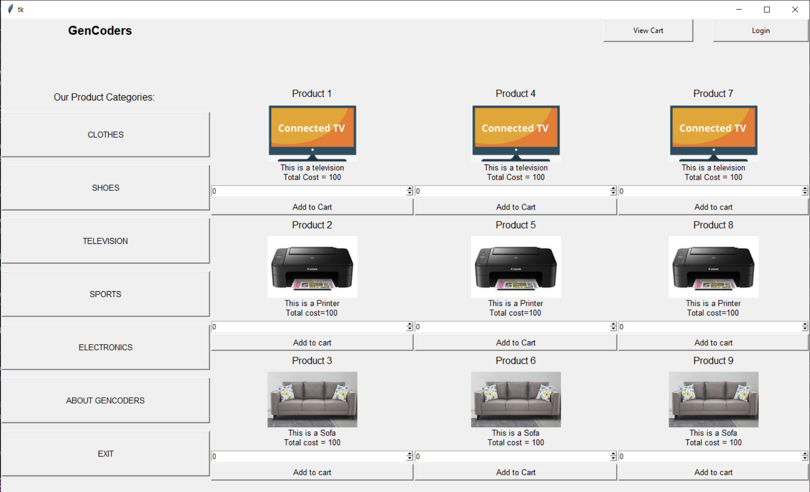

Home Page

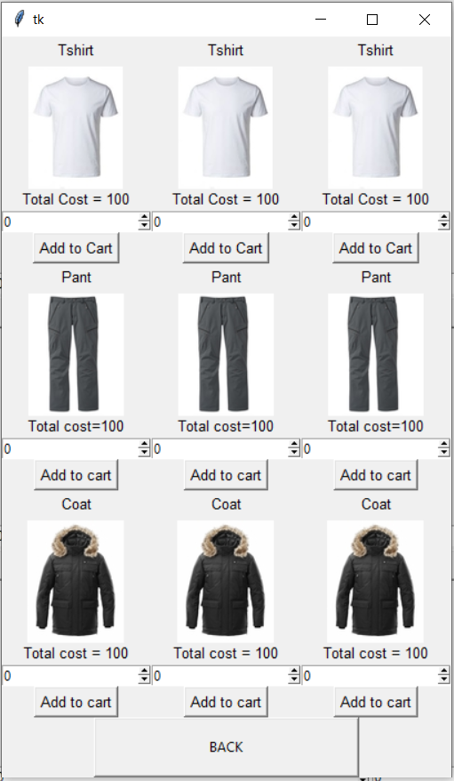

Clothes Page

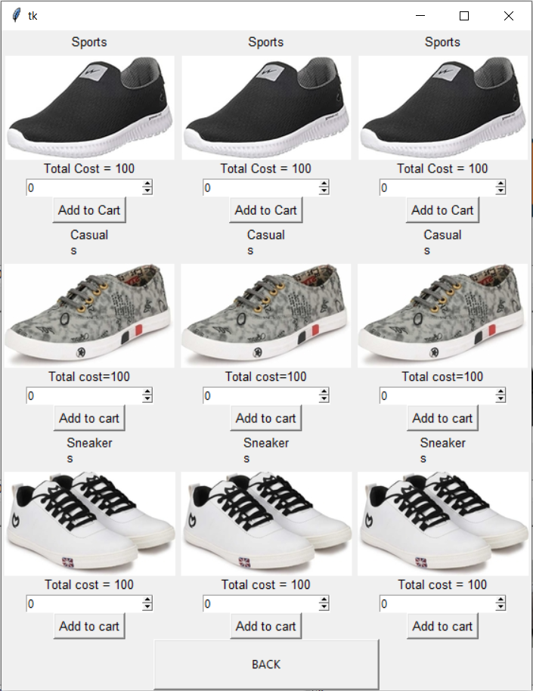

Shoes Page

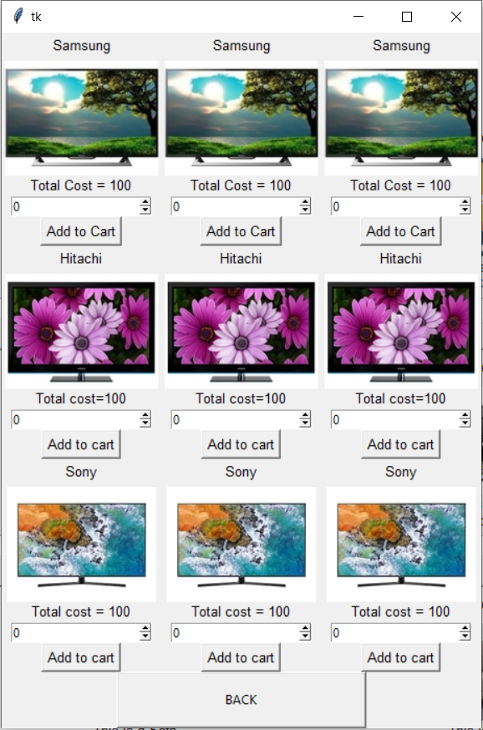

Television Page

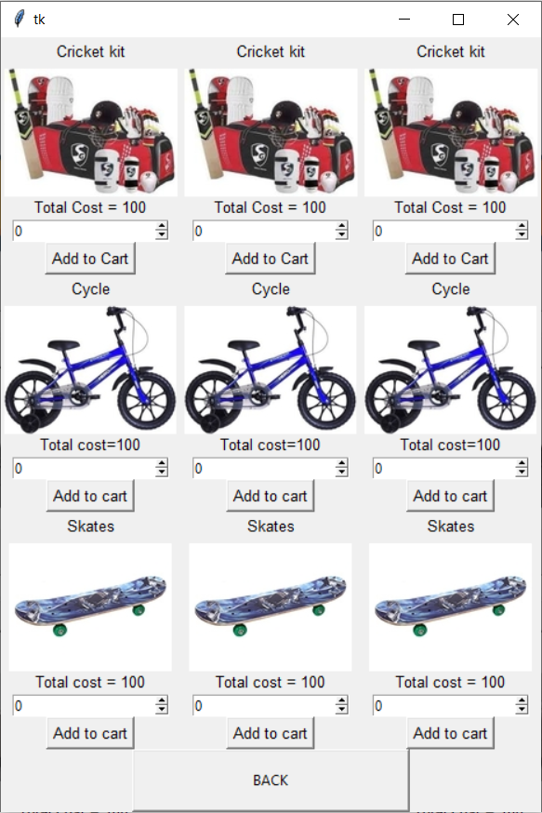

Sports Page

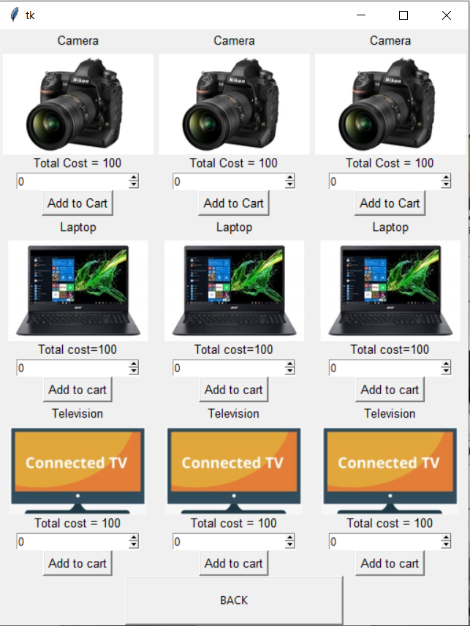

Electronics Page

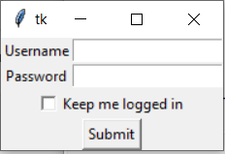

Login Page

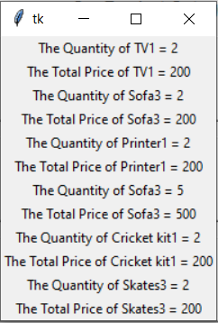

View Cart Page

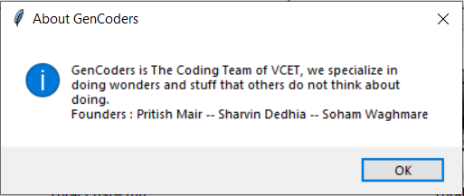

About GenCoders Page

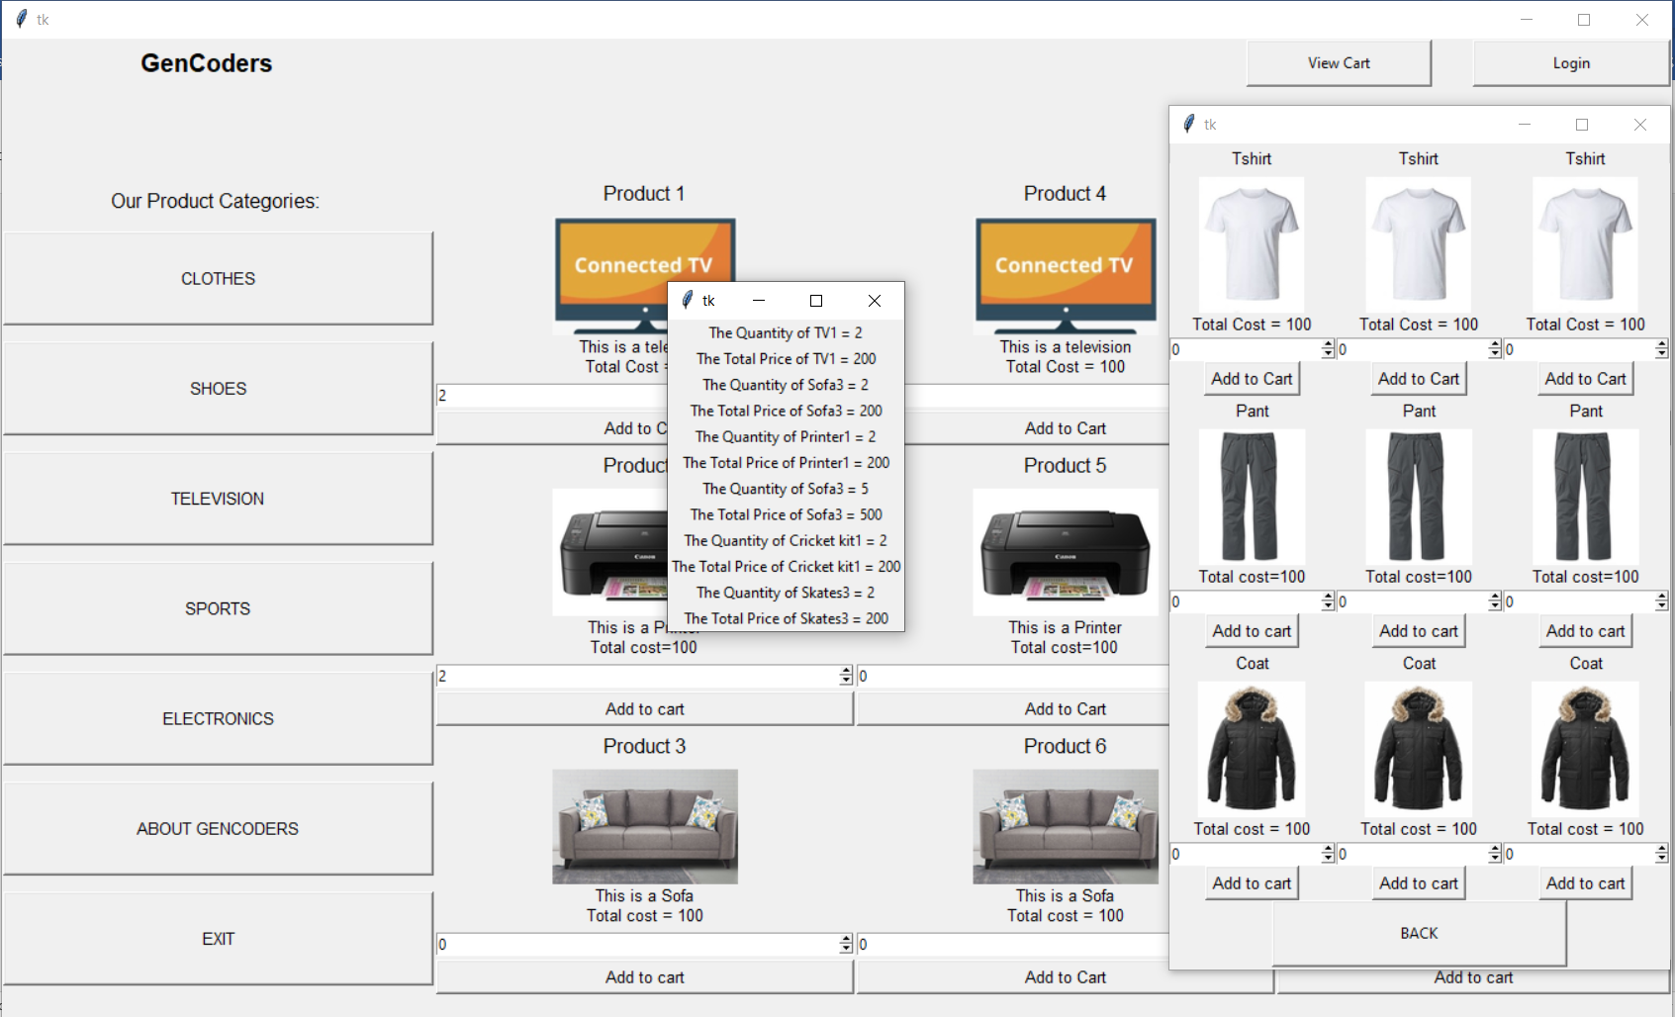

Combined Output